**LIST OF FIGURES**

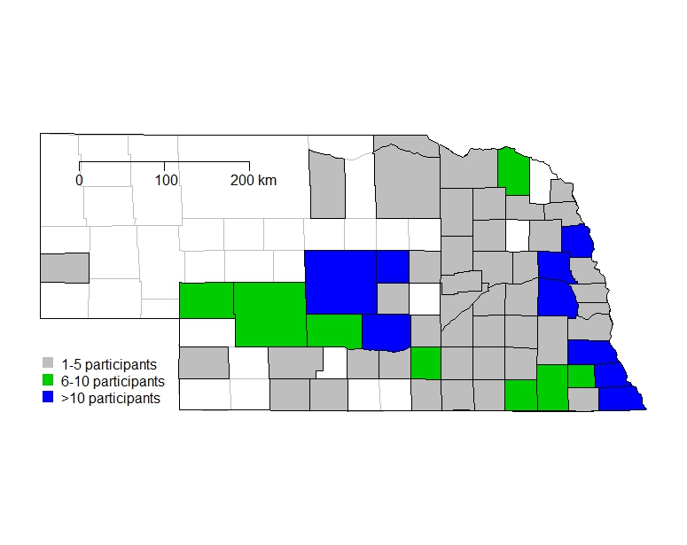

Figure 1. Nebraska counties represented in the survey. Different colors represent the number of answers obtained per county. The soybean production area of Nebraska is concentrated in the east, central and southern parts of the state.



Figure 2. Herbicides tank-mixed with dicamba and sprayed in dicamba-resistant (DR) soybeans in Nebraska. Complete responses (Q7-9 Table 1) from 63 farmers representing a total of 9,098 ha of DR soybean sprayed with dicamba were used to generate this figure.



Figure 3. Likelihood (logistic model; red line) of dicamba off-target injury in non-dicamba-resistant (DR) soybean fields in response to dicamba application time (day of the year; x-axis) in DR soybean. Responses from 30 participants were available to fit the model (Q 11, Table 1).